[](https://www.perthbraincentre.com.au/)

**Website URL**

**Live** : [**https://www.perthbraincentre.com.au/**](https://www.perthbraincentre.com.au/)

**To change popup content, follow these steps:**

1. To change the popup content, click on this icon.

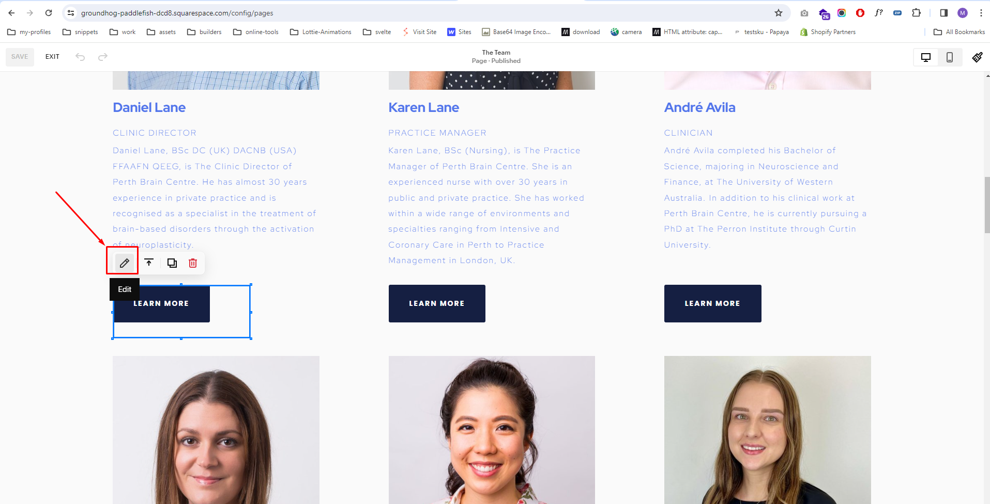

2. Then the code editor will open, click on the icon here to enlarge the view.

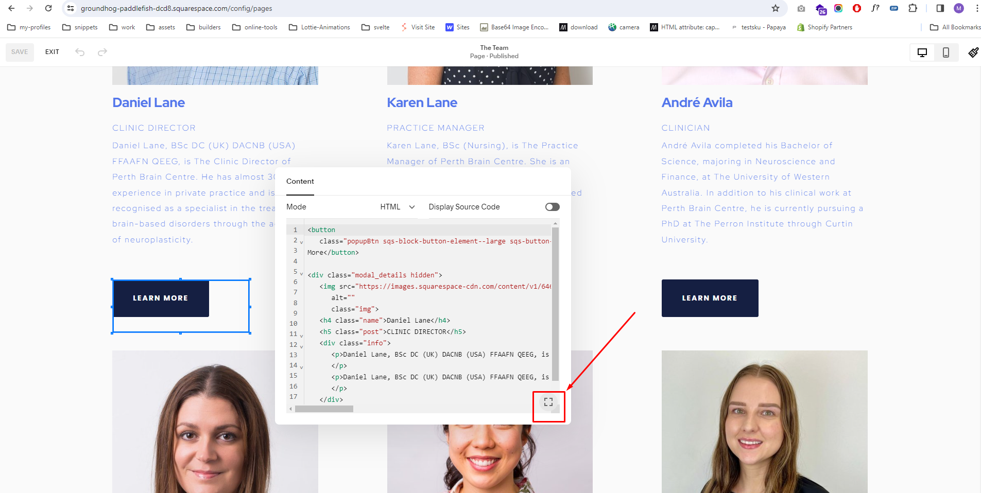

3. Please do not replace these tags, add text between them as shown in the screenshot.

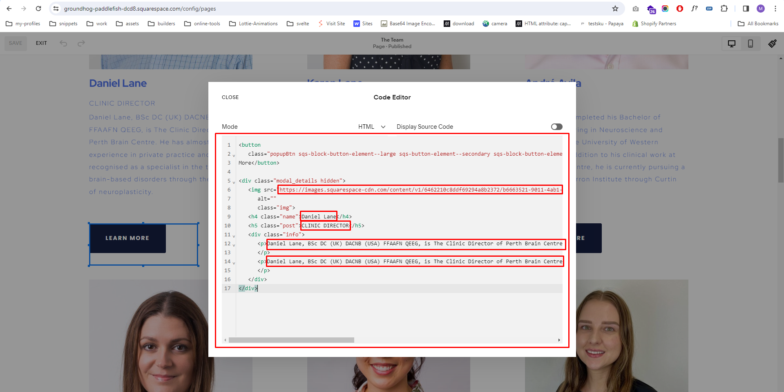

4. Save your changes.

5. Test the team popup to ensure that the updated content is displayed correctly.